MONTSERRAT
STATUTORY RULES AND ORDERS

S.R.O. 57 OF 2021

ROAD TRAFFIC (RACE AND SPEED TRIAL)
(DESIGNATION OF PLACE) ORDER

ARRANGEMENT OF ORDER

1. Citation 2
2. Designation of place 2
3. Application 2
4. Conduct of race or speed trial 2
5. Gatherings 3
6. Duration 3
7. Expiration 3
SCHEDULE 1 4
SCHEDULE 2 6
SCHEDULE 3 9
SCHEDULE 4 10
SCHEDULE 5 13
SCHEDULE 6 14

MONTSERRAT
STATUTORY RULES AND ORDERS
S.R.O. 57 OF 2021

ROAD TRAFFIC (RACE AND SPEED TRIAL)
(DESIGNATION OF PLACE) ORDER

THE ROAD TRAFFIC (RACE AND SPEED TRIAL) (DESIGNATION OF PLACE) ORDER 2021 MADE BY THE GOVERNOR ACTING ON THE ADVICE OF CABINET UNDER SECTION 55(1) OF THE ROAD TRAFFIC ACT (CAP. 7.06).
1. Citation
This Order may be cited as the Road Traffic (Race and Speed Trial) (Designation of Place) Order, 2021.
2. Designation of place
The place in the Cork Hill registration section along the Northern Main Road, which is more particularly described and shown in Schedule 1, is designated as a place to be used for a race or speed trial.
3. Application
(1) A person listed in —
(a) Column 1 of Schedule 2 is permitted to participate in a race or speed trial at the place designated in paragraph 2; and
(b) Column 2 of Schedule 2 is permitted to participate in a race or speed trial at the place designated in paragraph 2, except as a driver.
(2) A motor vehicle described in Schedule 3 may be used in a race or speed trial at the place designated in paragraph 2.
4. Conduct of race or speed trial
(1) A race or speed trial at the place designated in paragraph (2) shall be conducted—
(a) in the manner specified in Schedule 4; and
(b) in accordance with the by-laws of the Montserrat Motorsport Association.
(2) If the by-laws of the Montserrat Motorsport Association and this Order conflict, this Order prevails.
(3) The Montserrat Motorsport Association shall adhere to the COVID-19 protocols set out in Schedule 5.
5. Gatherings
Despite any rule to the contrary, the Montserrat Motorsport Association may accommodate a maximum of 150 persons at a race or speed trial event.
6. Duration
A race or speed trial may be conducted at the place designated in paragraph 2 on a day specified in Schedule 5, between 8 a.m. and 4 p.m.
7. Expiration
This Order expires on 31 July, 2022.

SCHEDULE 1
(paragraph 2)
DESIGNATION OF PLACE
That place in the Cork Hill registration section along the Northern Main Road which is marked as A on the map below and which is—
(a) bounded on the left in a northerly direction by—
(i) Block 9/06 Parcels 012 and 012/1;
(ii) Block 9/03 Parcel 129;
(iii) Block 9/03 Parcel 128;
(iv) Block 9/03 Parcel 126;
(v) Block 9/03 Parcel 125;
(vi) Block 9/03 Parcels 130 and 117;
(vii) Block 9/03 Parcel 116;
(viii) Block 9/03 Parcel 114; and
(ix) Block 9/03 Parcel 101;
(b) bounded on the right in a northerly direction by—
(i) Block 9/06 Parcel 015;
(ii) Block 9/04 Parcel 252;
(iii) Block 9/04 Parcel 185;
(iv) Block 9/04 Parcel 177;
(v) Block 9/04 Parcel 047;
(vi) Block 9/04 Parcel 046;
(vii) Block 9/04 Parcel 045; and
(viii) Block 9/04 Parcel 041; and
(c) measures approximately 670 meters in length and six meters in width.
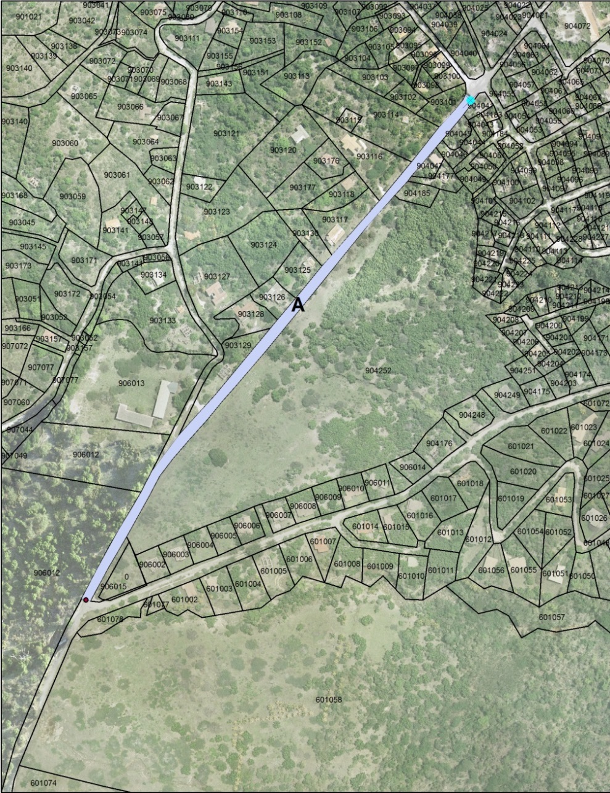

SCHEDULE 2
(paragraph 3(1))
PERSONS PERMITTED TO PARTICIPATE
IN A RACE OR SPEED TRIAL

Column 1 | Column 2
Alaine Bourn | The following registered nurses:
Alan Farara | Alex Ackie
Alvin Duberry | Danelda Henry
Andy Daley | Donique Layne
Anisa T. M. Lindsey | Lystra Fagan
Arlen Skerritt | Nadine Sweeney
Arnold Allen
Bertram Hickson | A member of the Royal Montserrat Police Service
Cameron Yearwood
Cedric Daley
Chivonne Gerald | A member of the Montserrat Fire and Rescue Service
Clinton Lewis
Curtley Pond
Daren Greer
Davelle Cabey | A medical practitioner registered under the Medical Act (Cap. 14.02)
Davikah Crichlow
Dennal Bramble
Denoy Camppbell
Devon Williams | Marshalls and pit crew members
Doniqueca Henry
Emari Estwick
Everson Farrell
Ezra Greer
Germaine Murraine
Gervaine Greenaway
Gilmore Williams
J’vhaun White
Jamaul Wade
James Adams
Jamilia F. L. Greenaway
Jason Halley
Jauvhed Warner
Jemuel Cabey
Jermaine Wade
Jerry Prince
Jervain R. Boatswain
John Osborne
Jouvelle Oliver
Jovarn E. M. Thornhill
Joven Greenaway
Jowayne Greenaway
Joyann Tuitt
Kayjason Martin
Keith Barzey
Keith Greenaway
Keithroy Martin
Kemar Bryant
Kenrick Hackett
Ke-Shawn Thornhill
Kwasi Ryan
Lerian Cassell
Lionel Baker
Louanna Joyce
Maria Silcott
Marlon Fergus
Marlena Fergus
Melvaughn Gerald
Meridith Lynch
Milykhia McKenzie
Nevis Drag Drivers – International Competitors
Nickyra Hickson
Oren Browne
Oswald West
Peter Wade
Philip Mulcare
Randall Murrain
Randy Fenton
Raymond Samuels
Renique Cassell
Reuel Hixon
Rhonda Boatwain
Rodney Browne
Rolston Daley
Sachin Redwood
Selvyn Maloney
Shammica Dash
Shane Cabey
Shaniece Moore
Shauvell Hixon
Shelzron Lee
Stefon Buffonge
Stephen Elwin
Stevel Rodney
Stevika T. A. Rodney
Terrence Tuitt
Terrod Chalmers
Terry Jerry Prince
Teshaun Wells
Thousland Galloway
Tora Cabey
Toya Martin
Trevorne Pond
Triston Jeffers
Twila Fenton
Victor James Jr.

SCHEDULE 3
(paragraph 3(2))
MOTOR VEHICLE IDENTIFICATION
The motor vehicles that may be used in a race or speed trial at the place designated in paragraph 2 are as follows:
- M17;
- M61;
- M72;
- M316;
- M422;
- M461;
- M606;
- M656;
- M658;
- M672;
- M702;
- M791;
- M828;
- M844;
- M847;
- M1288;
- M2092;
- M2107;
- M2582;
- M2592; and
- a motor vehicle that is built or modified for speed racing or speed trials but that is not licensed for use on a road.

SCHEDULE 4
(paragraph 4(1)(a))

CONDUCT OF A RACE OR SPEED TRIAL
1. | TRACK OFFICIALS
 | (a) | Pit Manager  A Pit Manager is in charge of the pit and shall facilitate the line-up of motor vehicles participating in a race or speed trial prior to the race or speed trial.
 | (b) | Pit Steward  A Pit Steward shall assist a Pit Manager in his duties as directed by the Pit Manager.
 | (c) | Pit Crew  The Pit crew shall assist in the maintenance of a motor vehicle used in a race or speed trial.
 | (d) | Flagman  A Flagman shall display the relevant flag at the start, during and at the end of a race or speed trial.
 | (e) | Assistant Flagman and Corner Flagman  An Assistant Flagman and Corner Flagman shall assist the Flagman in his duties as directed by the Flagman.
 | (f) | Chief Judge
 |  | A Chief Judge shall—
 |  | (i) | score the participants of a race or speed trial and post the final results and timing of all events; and
 |  | (ii) | submit all records and results to the Secretary of the Montserrat Motorsport Association at the end of a race or speed trial.
 | (g) | Judge
 |  | A Judge shall assist the Chief Judge in his duties as directed by the Chief Judge.
 | (h) | Referee
 |  | A Referee shall oversee a race or speed trial and liaise with other track officials during the race or speed trial.

2. | ATTIRE
 |  | A person permitted to participate in a race or speed trial shall—
 |  | (i) | wear or display a pit pass; and
 |  | (ii) | wear a high visibility vest.
3. | EQUIPMENT
 | (a) | A participant who is a driver in a race or speed trial shall be in possession of and use the following items in a race or speed trial—
 |  | (i) | a helmet;
 |  | (ii) | closed-toe shoes; and
 |  | (iii) | a two-way radio.
 | (b) | A participant who is a driver in a race or speed trial shall ensure that the motor vehicle to be used in the race or speed trial is equipped with the following items—
 |  | (i) | a seat belt;
 |  | (ii) | a firewall; and
 |  | (iii) | a hood over the engine and radiator.
4. | FLAGS
 | (a) | Green Flag  A green flag indicates the start of a race or speed trial.
 | (b) | Yellow Flag  A yellow flag indicates that a participant in a race or speed trial shall decelerate the motor vehicle.
 | (c) | Red Flag  A red flag indicates that a participant in a race or speed trial shall stop as soon as safely possible.
6. | GENERAL RULES
 | The general rules for a race or speed trial are as follows—
 | (a) | No more than two motor vehicles are allowed to participate in a race or speed trial.
 | (b) | The only person who is allowed in a motor vehicle during a race or speed trial is the driver of the motor vehicle.
7. | GENERAL PROCEDURES
 | The general procedures that a driver participating in a race or speed trial is expected to comply with are as follows—
 | (a) | A driver shall leave the pit and proceed to the start line at a maximum engine speed of 10 kilometres per hour.
 | (b) | A driver shall position the motor vehicle at the start line with the engine running.
 | (c) | The Pit Manager shall ensure that a motor vehicle is properly lined up at the start line.
 | (d) | The Flagman shall display the green flag to signal the start of the race.
 | (e) | A driver shall accelerate along the place designated under paragraph 2 and towards the finish line.
 | (f) | A driver shall drive away from the finish line and back to the pit in single file at a maximum engine speed of 20 kilometres per hour.

SCHEDULE 5
(paragraph 4(3))
COVID-19 PROTOCOLS
The Montserrat Motorsport Association shall:
- ensure that a person who wishes to attend a race and speed trial event undergoes thermal screening before attending a race and speed trial event;
- deny entry to any person who wishes to attend a race and speed trial event if the person has a body temperature above 98.6 degrees Fahrenheit, flu-like symptoms or any other Covid-19 symptom;
- ensure that a person who intends to attend a race and speed trial event applies hand sanitizer to his hands before attending a race and speed trial event;
- ensure that a person, except a race car driver who is driving alone, who intends to attend or participate in a race and speed trial event wears a face covering before attending a race and speed trial event and while at the place designated for a race or speed trial;
- post or cause to be posted notices, in conspicuous places at strategically placed hand sanitizer stations, which specifies that hand sanitizer should be used by each person who attends a race and speed trial event;
- post or cause to be posted a notice, in a conspicuous place at a race and speed trial event, which specifies that the wearing of a face covering is mandatory;
- shall demarcate three separate areas at a race and speed trial event which can accommodate no more than 50 persons in each demarcated area;
- ensure that no more than 50 persons are gathered in each demarcated area referenced at paragraph (g);
- ensure that track officials can be clearly identified through the use of badges, name tags, personalised clothing or otherwise; and
- ensure that a bar, food station, portable toilet and any other facility at a race and speed trial event is regularly cleaned and sanitized during a race and speed trial event.

SCHEDULE 6
(paragraph 5)
SPECIFIED DAYS
Month | Day
August 2021 | 1, 7, 8, 14, 15, 21, 22, 28, 29
September 2021 | 4, 5, 11, 12, 18, 19, 25, 26
October 2021 | 2, 3, 9, 10, 16, 17, 23, 24, 30, 31
November 2021 | 6, 7, 13, 14, 20, 21, 27, 28
December 2021 | 3, 4, 10, 11, 17, 18, 24, 25
January 2022 | 1, 2, 8, 9, 15, 16, 22, 23, 29, 30
February 2022 | 5, 6, 12, 13, 19, 20, 26, 27
March 2022 | 5, 6, 12, 13, 19, 20, 26, 27, 31
April 2022 | 2, 3, 9, 10, 16, 17, 23, 24, 30
May 2022 | 7, 8, 14, 15, 21, 22, 28, 29
June 2022 | 4, 5, 11, 12, 18, 19, 25, 26, 27
July 2022 | 2, 3, 9, 10, 16, 17, 23, 24, 30, 31

Made by the Governor acting on the advice of Cabinet this 22nd day of July, 2021.

CLERK OF CABINET

Published by exhibition by the Clerk of Cabinet at the Office of the Legislature, Farara Plaza, Brades, MSR1110, this day of , 2021.

CLERK OF CABINET

